Former MP shot dead in Kabul
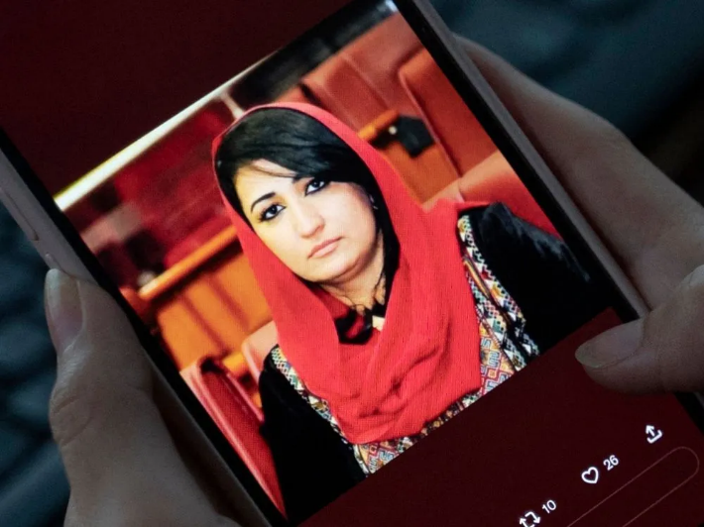
Mursal Nabizada, a former member of the Parliament, was shot dead at her home in Kabul on Jan. 15 Wakil Kohsar/Agence France-Presse — Getty Image

At her house, an ex-woman member of the Afghan parliament was shot and killed by unidentified assailants. Mursal Nabizada and her guard were just shot, killing them both, while her brother was hurt. The security forces have reportedly launched a thorough investigation into the incident in order to identify the offenders. Nabizada served in the legislature up until the Taliban assumed control in 2021 when Western forces began to leave the nation and many lawmakers fled.

It should be quite evident by this point that the world community was duped. The cruel, gendered-apartheid system of the Taliban commanders has returned, undoing the social progress made over the previous two decade
However, the international community, including the United States, has continued to retain political and security-related connections with the Taliban and continues to hold naively to yet another Taliban myth that it would destroy the Islamic State's affiliate in Afghanistan.
This blatant misinterpretation of reality actually heightens the global and American security threat over the long term.

Women are once more being erased from public transportation, employment opportunities, and post-secondary education.
These kinds of actions won't make things better overnight and may jeopardize the shaky relationship with the Taliban that is necessary to maintain the flow of urgently required international humanitarian aid. Efforts should be taken to prevent any disruption to humanitarian supplies.
However, Taliban leaders have so long felt impunity. Until they fulfill each and every one of their unfulfilled promises, they must endure the same suffering as the Afghan people.
The other option is to condemn the Afghan people to live through the same nightmare that my generation did and to do nothing as the country devolves further into anarchy and extremism, which may soon spread beyond the area to the coasts of the US.
https://www.nytimes.com/2023/01/19/opinion/afghanistan-taliban-women-security.html

