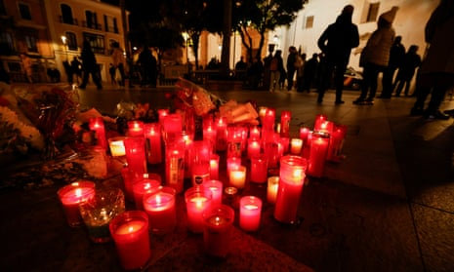
Guardian News and Media. (2023, January 27). Rightwing Spanish leaders under fire over anti-Islam comments after attack on Churches. The Guardian. Retrieved February 19, 2023, from https://www.theguardian.com/world/2023/jan/27/spain-algeciras-churches-attack-rightwing-leaders-islam-comments
Link to article:
https://www.theguardian.com/world/2023/jan/27/spain-algeciras-churches-attack-rightwing-leaders-islam-comments
Discrimination in Wake of Church Machete Attack
In Algeciras, Spain there was a violent machete attack on two churches that left 1 dead and 4 injured. The police have the suspect, who is a 25-year-old Moroccan man, in custody. The judge who’s investigating the incident suggests that this was a terrorist attack with ties to “Salafist jihadism.” The interior minister of Spain said that the suspect was a convicted illegal immigrant but had no prior indications of terrorism or radical behavior.
Spain’s right leaning Peoples party (PP) and far-right Vox party quickly pounced on the opportunity to use the crime as a political issue for a new cycle of elections. Which has been met with much criticism from Spain’s currently in power Socialist party and anti-racism groups. The PP’s leader, Alberto Núñez Feijóo, stated that some people kill in the name of their religion, “however, it’s been many centuries since we’ve seen a Catholic or a Christian killing in the name of their religion or their beliefs. But there are other peoples who have citizens who do that.” This resulted in major backlash and Núñez Feijóo attempting to walk back his remarks. Vox’s leader Santiago Abascal blamed illegal immigration and the government “opening up the borders and spraying around subsidies.”
To me it is no surprise that the conservative leaders reacted this way. We’ve seen it plenty of times before in the US. Algeciras is near the southern tip of Spain which is very close to Africa and is home to an important port with ferry connections to northern Africa. Which makes it a contentious part of the country in terms of immigration. And in my opinion the reaction of Islamophobia and border restriction was the easy way out and a cheap tactic at garnering more support for the upcoming election. Thankfully though, religious officials of the attacked churches have come out with statements on Christian and Muslim cooperation. With one of the priests saying that Muslims make up ¾ of those who use the church’s charitable services. And the general secretary of the Spanish Episcopal conference pleading that “we cannot fall into the easy discourse of demonizing an entire collective.” Which is admirable and would certainly be welcome here in the US.

