Nick Baker
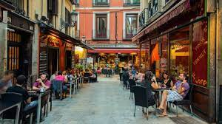
Cuesta De Andrés, S. (2015, June 10). The 9 best bars in Madrid, Spain. Culture Trip. Retrieved March 26, 2023, from https://theculturetrip.com/europe/spain/articles/the-10-best-bars-in-madrid/
Spanish Residents vs Spanish Revelers
In cities across Spain, residents are becoming increasingly agitated with the noise of the nightlife surrounding their homes. Citizens have started putting posters up in the streets begging for quiet and organizing in efforts to get government officials attention regarding the situation. With COVID restrictions being lifted, the bars and clubs are oftentimes open til 5:30. People then spill out on to the street and disturb those who live nearby. Furthermore, the measures put in place to combat the spread of COVID encouraged the hospitality industry to serve their guests outdoors. Which has also been a cause for the uptick in noise.
The government is contemplating inputting laws that would allow some bars to be closed earlier at times. But the hospitality industry has met that with strong backlash since the terraces have been a lifesaver in the face of rising costs and labor shortages. Some theorize that the bars themselves aren’t the problem, it’s the people. Apparently, Spaniards are a loud voiced nationality. In Barcelona they installed noise monitors in the streets. Some areas had average decibel levels of 70 to 75. The World Health Organization defines 55 decibels as the point where noise becomes dangerous to human health. It will be interesting to see how a solution is realized.

