Activity 8: Annotated Bibliography

Purpose of this assignment: The goal of this assignment is to identify relevant papers from the published literature to help you develop your project.

How does it fit within the entire project? The publications you will find and analyze will help you identify the dialogue around your research topics, develop analyses, compare your results to previous findings, and place them in a broader context.
Tasks required: Read five articles following the methods demonstrated in class and complete the activity below.

Deliverable:
- Completed copy of this handout uploaded on [LMS] by [due date].
- A PDF copy of each paper you are summarizing uploaded to the [online shared folder] for your project.

Estimated time: About two hours and a half

Group work or individual work? Individual work requiring group coordination.

Note to instructor:
- Also include guidelines from the library services of your institution on how to incorporate direct access to articles in Google Scholar as well as how to find articles not directly accessible via Google Scholar.

Step-by-step:
- Use your answers to the mind mapping activity to identify below keywords associated to your project:

- Go to https://scholar.google.com/. Use the keywords you identified to search for relevant papers.

- Click on the link to the papers that have cited the most relevant publications to find additional papers:

- Consider also clicking on the “related articles” link for other suggestions:

- Enter the title of each of the papers provided to you at the start of the semester. Search for papers that have cited these publications and related research.

- Look at the authors of the paper you find. Are there authors that have published multiple papers on a topic of interest to you? Look at their other publications. Some authors have a Google Scholar profile (their name is underlined), for those who do not, consider searching by authors in Google Scholar or search for their website.
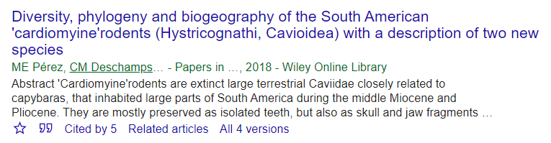

- Search the literature cited/references of the papers you find to get older papers. Use the search function of Adobe Acrobat Reader and keywords to find other references cited in the papers you have found. You can apply these techniques to the papers I provided you at the start of the semester.

- Use this tool: https://www.connectedpapers.com/. Enter the title of a paper to explore related papers and find papers central to the conversations.

- You should coordinate with your teammates to avoid overlaps in publications among you. Your literature review should only be based on [scientific] publications (peer-reviewed articles, university press books/book chapters). If you are unsure whether or not a publication is appropriate, feel free to check with me. For a minimum of five publications, you should provide:

- Full reference (title, authors, journal…) formatted as in the Journal of Morphology (see https://tinyurl.com/ycm7u9r8)
- Summary of the paper (<100 words)
- Why it is important to your research (i.e. what you will gain from it) in <100 words

Very important notes from the Library system:

[If you do not see OhioLink hyperlinks in your results, you must do the following:

Go to Google Scholar (http://scholar.google.com)
Click on the hamburger button.
Click on "Settings" near the gear.
Click on "Library Links" on the left side
Type OhioLINK in the text box and hit enter
OhioLINK-Find it with OhioLINK will now appear below that text box
Be sure the check box next to it IS checked
Click on "Save" at the top or bottom
Search with the OhioLINK connection!
If you are off-campus, you must ALSO do the following:

Open a new tab in your browser
Go to this address: https://auth.ohiolink.edu/DS/
Select Ohio State University
Select OARDC campus (this is the other Wooster campus)
Log in with your name.#
You will see a page for OhioLINK databases; leave this tab open while searching Google Scholar with the OhioLINK connection!]

[Use these Ohio State Libraries' services if you do not find free full text through Google Scholar:
- Research Databases List: search or browse by database name or browse by subject. Many database have full text or use Find It! to locate available full text provided by the Ohio State Libraries or OhioLINK.
- Online catalog: search by journal title or book title.
- Online Journals List: search or browse by journal title.
Request a copy via the Ohio State Libraries' Interlibrary Services.]

