Algorithm for Extra-Label Drug Use

Flowchart
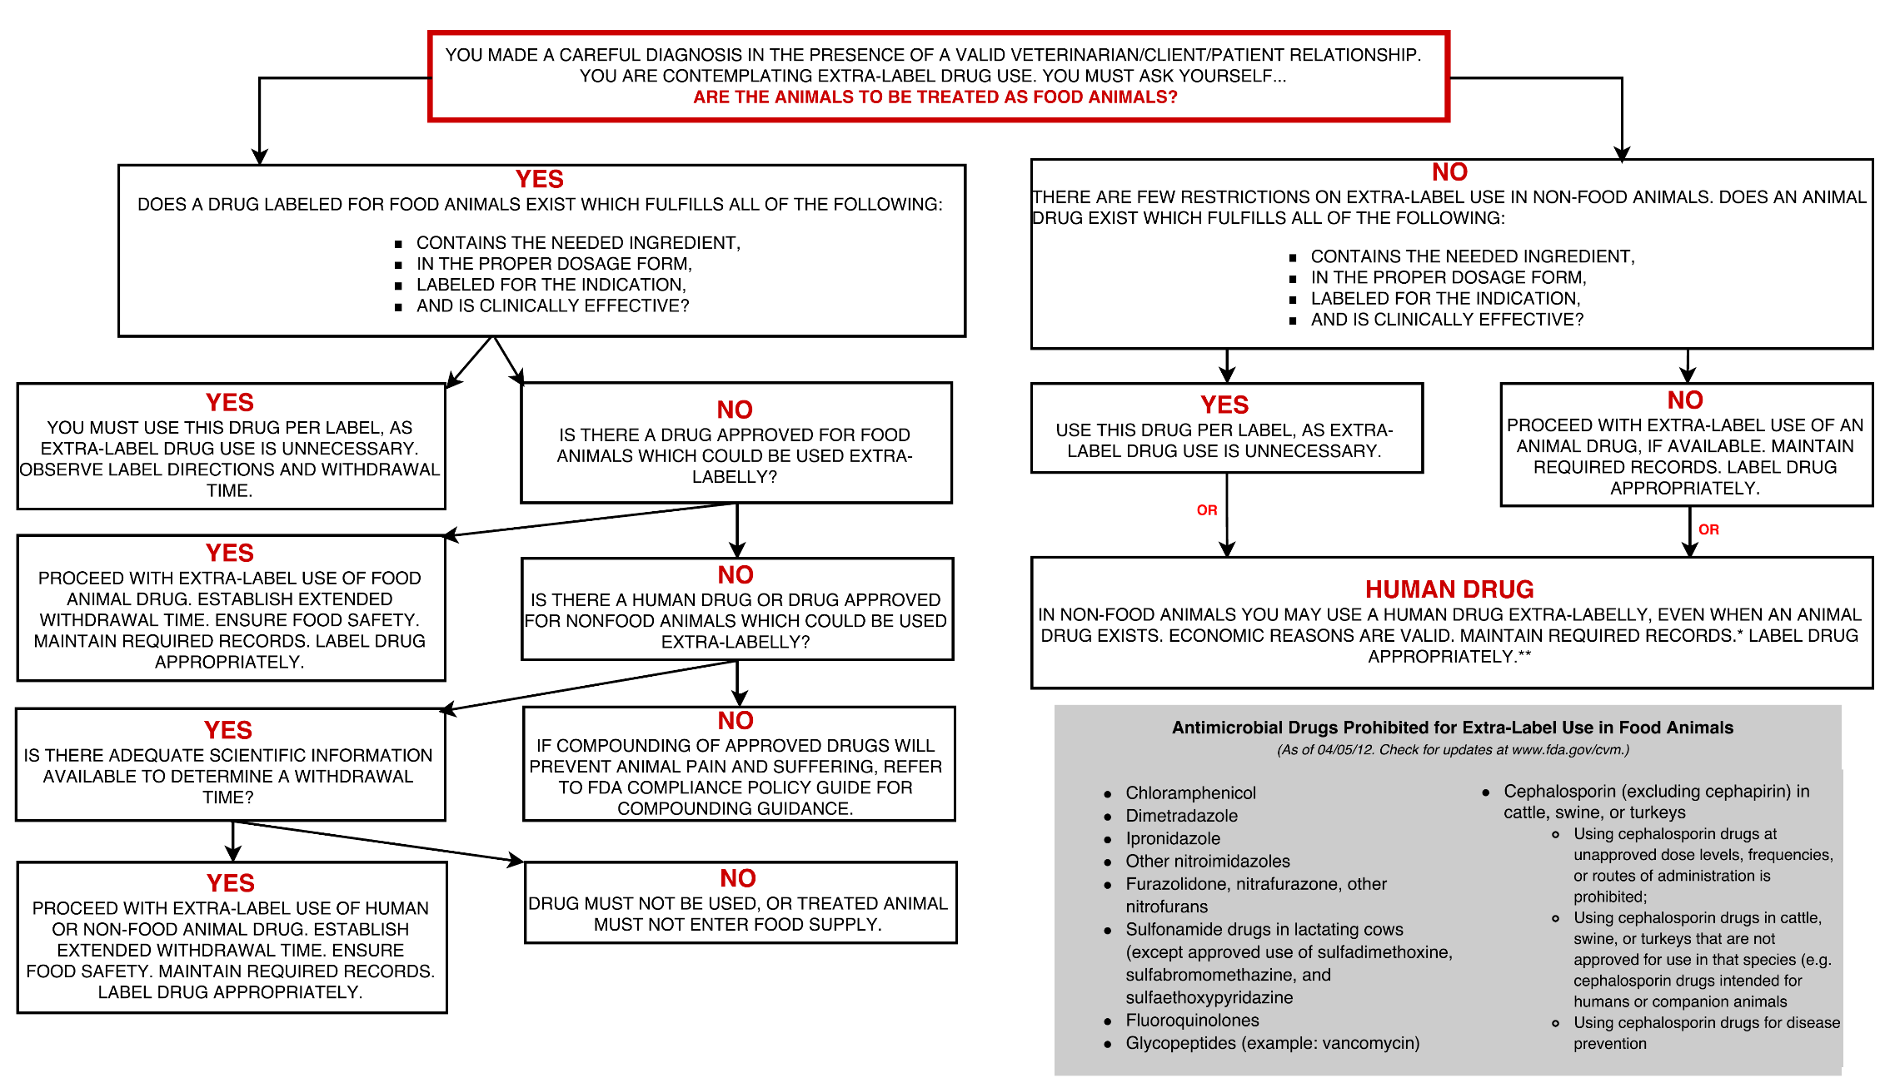

Description

Title: “You made a care diagnosis in the presence of a valid veterinarian/client/patient relationship. You are contemplating extra-label drug use. You must ask yourself …”

Top of chart begins Q: "Are the animals to be treated as food animals?"

- If “No” to treating as food animals, then Q: “There a few restrictions on extra-label use in non-food animals. Does an animal drug exist which fulfills all of the following: 1) contains the needed ingredient, 2) in the proper dosage form, 3) labeled for the indication, and 4) is clinically effective?”
  - Note: In either case, in non-food animals you may use a human drug extra-labelly, even when an animal drug exists. Economic reasons are valid. Maintain required records. Label drug appropriately.
  - If “Yes” to non-food animal drug meeting restrictions, then “Use this drug per label, as extra-label drug use is unnecessary.”
  - If “No” to non-food animal drug meeting restrictions, then “Proceed with extra-label use of an animal drug, if available. Maintain required records. Label drug appropriately.”
- If “Yes” to treating as food animals, then Q: “Does a drug labelled for food animals exist which fulfills all of the following: 1) contains the needed ingredient, 2) in the proper dosage form, 3) labeled for the indication, and 4) is clinical effective?”
  - If “Yes” to food animal drug meeting restrictions, then “You must use this drug per label, as extra-label drug use is unnecessary. Observe label directions and withdrawal time.”
  - If “No” to food animal drug meeting restrictions, then Q: “Is there a drug approved for food animals which could be used extra-labelly?”
    - If “Yes”, then “Proceed with extra-label use of food animal drug. Establish extended withdrawal time. Establish food safety. Maintain required records. Label drug appropriately”.
    - If “No”, then Q: “Is there a human drug or drug approved for non-food animal which could be used extra-labelly?”
      - If “No”, then “If compounding of approved drugs will prevent animal pain and suffering, refer to FDA compliance policy guide for compounding guidance.”
      - If “Yes”, then Q: “Is there adequate scientific information available to determine a withdrawal time?”
        - If “Yes”, then “Proceed with extra-label use of human or non-food animal drug. Establish extended withdrawal time. Ensure food safety. Maintain required records. Label drug appropriately.”
        - If “No”, then “Drug must not be used, or treated animal must not enter food supply.”

